The Band Department

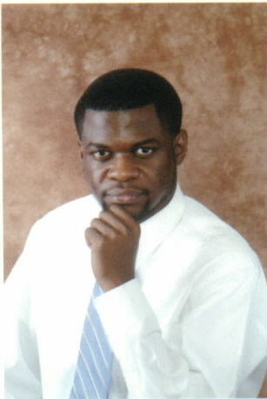

Of The

# Booker T. Washington

**New Technology High School**

**2104 Milam Street**

**Shreveport, LA 71103**

## Ms. Betty Jordan, Principal

Mr. Emmanuel Hudson, Director of Bands

STUDENT INFORMATION SHEET

NAME ___________________________________________ GRADE (2011-2012)______

ADDRESS____________________________________________________________________________

STREET CITY ZIP CODE

HOME PHONE___________________________________________ CELL PHONE_______________

INSTRUMENT ___________________________________ # OF YEARS PLAYED_____

(If you haven’t played this instrument, you will be taught how in the Beginning Band Class)

PARENT(S) OR GUARDIAN(S)__________________________________________________________

ADDRESS (*IF DIFFERENT FROM STUDENT)______*_____________________________________________

PHONE NUMBER (*IF DIFFERENT)*_____________________________________

EMERGENCY CONTACT PERSON___________________________________________

PHONE NUMBER FOR EMERGENCY CONTACT PERSON___________________________-

PLEASE LIST BELOW ANY MEDICAL CONDITIONS THAT THE BAND DIRECTOR SHOULD BE AWARE OF:

____________________________________________________________________________________________________________________________________________________________________________________________________________________________________________________________________________________________________________________________________________________

**PARENTAL CONSENT**

My signature below indicates that (1) I am aware of my child’s participation in the band and (2) certify that there are no medical conditions that would prevent him/her in participating in the band program.

Child’s Name___________________________________ Parent Signature________________________